




HOLISTIC TEACHING PERFORMANCE INTELLIGENCE

Project Domain
[Excel / Power BI with Copilot]

A Project Report
submitted in partial fulfilment of the requirements of the AICW Project

by:



Faculty Name
Ms.Karthikeyani V
S Email
Karthikaviswanath36@gmail.com
Guide
Ms.Uma Maheswari R

Institution:
VELTECH RANGARAJAN Dr.SAGUNTHALA R&D INSTITUTE OF SCIENCE AND TECHNOLOGY

Year - 2026
ACKNOWLEDGEMENT

We express our sincere gratitude to everyone who supported us during the project Student Feedback & Teaching Improvement Analyzer - Holistic Teaching Performance Intelligence

First, we extend our heartfelt thanks to our guide, Ms.R.Uma Maheshwari, for her constant guidance, encouragement, and valuable suggestions. Her support gave us confidence and helped us complete this project successfully.

We are also grateful to the Edunet Foundation, Microsoft, LinkedIn, and SAP for providing us with this fellowship opportunity and the resources to learn and showcase our AI skills.

Our special thanks go to our institution, VelTech Rangarajan Dr.Sagunthala R&D Institute of Science and Technology, for providing the facilities and support needed throughout the project.

Finally, we are deeply thankful to our family and friends for their continuous motivation and encouragement, which kept us going during this journey.

ABSTRACT OF THE PROJECT
This project, undertaken as part of the AICW (Artificial Intelligence in the Contemporary World) Fellowship Program, supported by Edunet Foundation in partnership with Microsoft, LinkedIn, and SAP focuses on leveraging Artificial Intelligence and data analytics to enhance the analysis of student feedback in higher education. Traditional feedback systems largely rely on numerical ratings, often overlooking the valuable insights embedded in qualitative comments, leading to incomplete evaluation of teaching effectiveness.
The primary objective of this project is to develop a holistic feedback analysis framework that integrates both quantitative and qualitative data to provide deeper insights into faculty performance. The study utilizes tools such as Microsoft Excel, Power BI, and AI-powered assistants like Microsoft Copilot to clean, process, and analyze structured datasets along with sentiment analysis of textual feedback.
The methodology involves data preprocessing, including handling missing values, standardizing rating scales, and categorizing feedback parameters such as engagement, conceptual clarity, innovation, and accessibility. AI-based sentiment analysis is applied to student comments to classify them into positive, neutral, and negative sentiments. Further, pivot table analysis and interactive dashboards are created to visualize parameter-wise performance, faculty strengths, and areas for improvement.
Key results indicate that combining sentiment analysis with traditional scoring provides a more comprehensive evaluation of teaching effectiveness. The dashboard enables stakeholders to identify high-performing faculty, detect patterns in student satisfaction, and make data-driven academic decisions.
In conclusion, the project demonstrates that integrating Artificial Intelligence with feedback systems significantly enhances the quality of insights, supporting continuous improvement in teaching and learning outcomes.

TABLE OF CONTENTS
S. No. | Chapter / Section | Page No.
 | Abstract of the Project | 3
 | List of Figures | 5
 | List of Tables | 5
1 | Chapter 1 — Introduction | 6
1.1 | Problem Statement
1.2 | Motivation
1.3 | Objectives
1.4 | Scope of the Project
2 | Chapter 2 — Literature Survey | 10
2.1 | Existing work and Research
2.2 | Tools and Technology Review
2.3 | Gaps Identified
3 | Chapter 3 — Proposed Methodology | 12
3.1 | System Design
3.2 | Modules / Components Used
3.3 | Data Flow Diagram (DFD)
3.4 | Advantages
3.5 | Requirement Specification
4 | Chapter 4 — Implementation and Results | 18
4.1 | Data Cleaning Results
4.2 | Visualization / Output Results
4.3 | AI Tool Integration Results
5 | Chapter 5 — Discussion and Conclusion | 32
5.1 | Key findings
5.1.1 | data quality and categorisation
5.1.2 | Quantitative Insights
5.1.3 | Qualitative Insights
5.1.4 | AI-Driven Efficiency gains
5.2 | Limitations
5.3 | Future work
5.4 | Conclusion
 | References
 | Appendices
 | Appendix A – Sample Dataset
 | Appendix B- Key Excel Formulas / Power Query steps used
 | Appendix C- AI Prompts used | 37
 | Appendix D — Screenshot Gallery | 38

List of Figures
Figure No. | Figure Title / Description | Page No.
Figure 1 | Data Flow Diagram (DFD) | 14
Figure 2 | Raw / uncleaned dataset screenshot | 19
Figure 3 | Cleaned dataset or validation summary screenshot | 19
Figure 4 | Department-wise Faculty Performance | 21
Figure 5 | Faculty Performance Summary | 22
Figure 6 | Course-Wise Satisfaction | 24
Figure 7 | Faculty overall Performance Analysis | 26
Figure 8 | Main dashboard | 28
Fig A1 | Pivot Table | 38

List of Tables

Table No. | Table Title / Description | Page No.
1 | Data Process Flow | 15
2 | Hardware Requirements | 17
3 | Software Requirements | 17
4 | Department-wise Faculty Performance | 20
5 | Faculty Performance Summary | 23
6 | Course wise Satisfaction | 24
7 | Faculty overall Performance Analysis | 27
8 | Tools Used in Project | 30
9 | List of Prompts Used in Project | 31

CHAPTER 1
Introduction
In the contemporary educational landscape, the integration of data-driven approaches has become essential for enhancing teaching quality and student learning outcomes. Student feedback, collected periodically at the end of courses or semesters, serves as a vital tool for evaluating instructional effectiveness, course design, and overall academic experience. It provides institutions with valuable insights into key dimensions such as engagement, conceptual clarity, accessibility, and innovation in teaching. However, despite the increasing volume of feedback data generated, its effective utilisation remains a significant challenge.
Traditional feedback analysis methods primarily focus on numerical ratings, offering only a surface-level understanding of teaching performance. While these quantitative metrics are easy to process, they fail to capture the depth and nuance present in qualitative comments shared by students. These textual responses often contain critical insights, suggestions, and sentiments that can significantly contribute to improving teaching practices. However, analysing such unstructured data manually is both time-intensive and prone to inconsistencies and bias.
With the advent of Artificial Intelligence (AI) and advanced analytics tools such as Microsoft Excel, Power BI, and Microsoft Copilot, there is a growing opportunity to transform traditional feedback systems into intelligent, automated, and insight-driven frameworks. These technologies enable efficient data cleaning, sentiment analysis, pattern recognition, and interactive visualization, thereby unlocking the full potential of both structured and unstructured feedback data.
This project is developed in the context of the AICW (Artificial Intelligence in the Contemporary World) Fellowship Program, which aims to equip learners with practical skills in AI, data analytics, and business intelligence. The study focuses on designing a holistic feedback analytics system that integrates quantitative scores with AI-driven sentiment analysis to provide a more comprehensive evaluation of faculty performance.
By leveraging AI-powered tools and analytical techniques, the project seeks to bridge the existing gaps in feedback analysis, enabling institutions to make informed decisions, enhance teaching effectiveness, and promote continuous improvement in the overall educational ecosystem.
1.1 Problem Statement
Student feedback plays a critical role in evaluating teaching effectiveness and ensuring quality assurance in educational institutions. However, existing feedback systems are largely limited in their ability to extract meaningful and actionable insights from the data collected. Most systems primarily rely on quantitative ratings, while qualitative feedback—rich in context and detail—remains underutilized due to the challenges of analysing unstructured data.
- The current feedback system predominantly relies on quantitative ratings, failing to effectively capture and analyse qualitative student comments, thereby limiting the depth of insights into teaching effectiveness.
- The absence of AI-driven automation in analysing unstructured feedback results in time-consuming, manual processes that are prone to bias and inefficiency.
- Existing systems do not address feedback bias caused by uneven student participation, leading to potentially skewed and unreliable evaluation outcomes.
- The lack of multi-source evaluation, including peer reviews and faculty self-assessment, results in a one-dimensional perspective of teaching performance.
- There is no structured mechanism to track the implementation of feedback-based recommendations, preventing institutions from measuring improvement and closing the feedback loop effectively.
1.2 Motivation
The motivation for undertaking this project stems from the increasing need to transform traditional student feedback systems into more intelligent, data-driven decision-making tools. As an academic professional, analysing student feedback is a routine yet critical task for improving teaching effectiveness and enhancing the overall learning experience. This project is personally meaningful as it addresses a real challenge faced in academic environments and provides an opportunity to integrate innovative solutions into everyday teaching practices.
By utilising tools such as Microsoft Excel, Power BI, and Microsoft Copilot, the project demonstrates how modern technologies can be applied to extract deeper insights from both structured and unstructured data. The ability to perform sentiment analysis, identify patterns, and visualize results through interactive dashboards enhances the efficiency and accuracy of feedback analysis.
In terms of real-world applications, this project can be implemented in educational institutions to support faculty evaluation, curriculum improvement, and strategic academic planning. It can assist administrators in identifying strengths, addressing weaknesses, and making informed decisions that directly impact student satisfaction and learning outcomes.
1.3 Objectives
The main objectives of the project are:
- To develop an AI-driven system for automated analysis of student feedback, including sentiment analysis and summarisation of unstructured textual data.
- To integrate multi-source evaluation data such as student feedback, peer reviews, and faculty self-assessments to provide a comprehensive assessment of teaching effectiveness.
- To design a bias-aware and context-sensitive analysis framework that accounts for feedback response bias and variations in course difficulty for fair evaluation.
- To incorporate student demographic segmentation in feedback analysis to generate targeted and meaningful insights for different learner groups.
- To create an interactive dashboard with AI-driven recommendations and a feedback-to-action tracking mechanism to support continuous improvement in teaching and learning outcomes.
1.4 Scope of the Project

This project focuses on analysing student feedback data collected from higher educational institutions, which includes both structured data (numerical ratings across parameters such as engagement, clarity, and innovation) and unstructured data (textual comments provided by students). The dataset represents feedback collected at the end of academic courses and is used to evaluate teaching effectiveness and overall learning experience.
The tools used in this project are limited to Microsoft Excel, Power BI, Microsoft Copilot, and AI chatbot platforms as part of the AICW Fellowship guidelines. These tools are utilized for data cleaning, transformation, sentiment analysis, prompt-based insights, and interactive dashboard creation.
The analysis primarily focuses on key areas such as data preprocessing, sentiment analysis of qualitative feedback, pivot table-based evaluation, and visualization of insights through dashboards. It also emphasizes identifying faculty performance trends, strengths, and areas for improvement using AI-assisted techniques.
However, the project does not include real-time data integration with institutional systems, advanced predictive modelling, or the development of machine learning algorithms for forecasting. It also excludes the implementation of a fully automated feedback management system.
This project is developed as part of a fellowship program and is intended to demonstrate practical application of AI and data analytics concepts. It is not designed as a production-level system but as a prototype showcasing the potential of AI-driven feedback analysis in an academic environment.

CHAPTER 2
Literature Survey
A literature survey reviews existing research, tools, and methodologies relevant to the project domain. It helps identify gaps that the current project aims to address.
2.1 Existing Work and Research
A significant body of research and practical implementations exists in the domain of feedback analysis, data analytics, and business intelligence. Traditional approaches to student feedback analysis primarily rely on spreadsheet-based tools such as Microsoft Excel, where techniques like data cleaning, filtering, and pivot table analysis are commonly used. These methods are effective for handling structured data; however, they offer limited capability in processing unstructured textual feedback and extracting deeper insights.
With the advancement of business intelligence tools such as Power BI, interactive dashboards and real-time reporting have become widely adopted. Existing Power BI templates and dashboards enable institutions to visualize key performance indicators, compare faculty performance, and track trends over time. However, these systems still largely depend on numerical inputs and lack integration with advanced AI techniques for qualitative data analysis.
Recent developments in Artificial Intelligence, particularly with tools like Microsoft Copilot and AI chatbots, have introduced new possibilities in automating data analysis. Research on AI-assisted data cleaning and prompt engineering demonstrates that AI can efficiently perform tasks such as sentiment analysis, summarization, and pattern recognition in textual data. Studies in this area highlight improved efficiency, reduced manual effort, and enhanced decision-making capabilities.
Despite these advancements, several limitations remain in existing solutions. Most systems focus on single-source feedback (primarily student evaluations), neglecting multi-source inputs such as peer reviews and self-assessments. Additionally, feedback bias and uneven participation are rarely addressed, leading to potentially skewed insights. Existing models also lack contextual analysis, where course difficulty and subject-specific variations are not considered. Furthermore, there is limited emphasis on closing the feedback loop by tracking the implementation and impact of suggested improvements.
This project aims to bridge these gaps by integrating AI-driven sentiment analysis with traditional data analytics, enabling the processing of both structured and unstructured data. It introduces a more holistic framework that enhances insight generation, supports better academic decision-making, and moves towards a more comprehensive and intelligent feedback evaluation system.

2.2 Tools and Technologies Review
- Microsoft Excel Used for data cleaning, transformation, and basic visualization. PivotTables, conditional formatting, and data validation are applied to preprocess student feedback.
- Microsoft Power BI Provides interactive dashboards and visualizations. Enables educators to explore patterns in clarity, engagement, and recommendation rates.
- Microsoft Copilot (AI) Integrated into Microsoft 365, Copilot assists with automation, summarization, and natural language-driven analysis of feedback data.
- AI Chatbots (e.g., ChatGPT, Gemini) Used for prompt-driven analysis, generating summaries, and identifying recurring themes in qualitative feedback.
- Additional Tools
  - Public Repositories (GitHub/OneDrive) for sharing project artifacts and demonstration videos.

2.3 Gaps Identified
- Most existing literature emphasizes complex machine learning models, while simpler tool-based solutions for non-technical users are underexplored.
- Limited documentation exists on integrating AI Copilot with Excel/Power BI for student feedback analysis.
- Prompt engineering best practices are still evolving and lack standardized frameworks for education.
- Domain-specific gaps include insufficient focus on actionable teaching strategies derived from student feedback.
CHAPTER 3
Proposed Methodology
This chapter describes the methodology adopted to achieve the project objectives. It covers the system design, modules used, data flow, advantages, and requirement specifications.
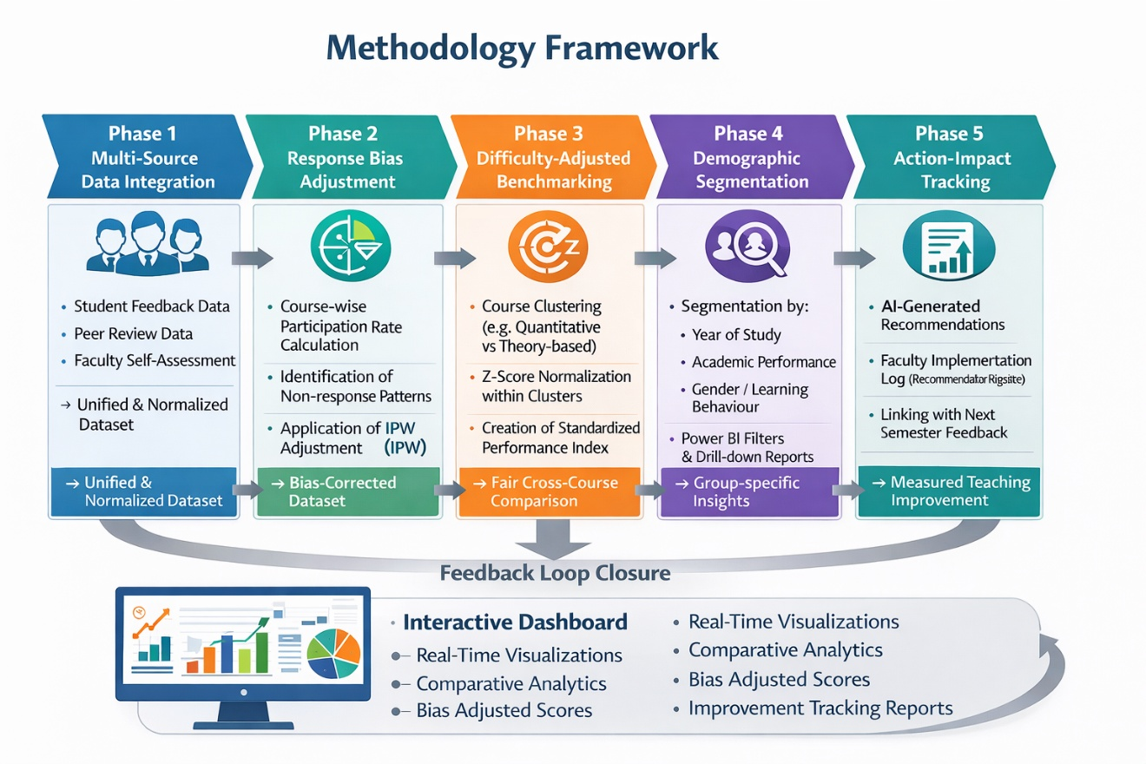

3.1 System Design
The proposed methodology for this project focuses on developing an AI-driven framework to analyse student feedback by integrating both quantitative and qualitative data. The approach is structured into multiple stages to ensure systematic data processing, analysis, and visualization.
1. Data Collection Student feedback data is collected from institutional sources, including structured ratings (e.g., engagement, clarity, innovation, accessibility) and unstructured textual comments. The dataset represents end-of-course feedback used for evaluating teaching effectiveness.
2. Data Preprocessing and Cleaning The collected data is cleaned using Microsoft Excel. This involves handling missing values, removing duplicates, standardizing rating scales, and ensuring consistency in parameter naming. Text data is also preprocessed by correcting formatting issues and removing irrelevant content.
3. Data Transformation and Structuring The dataset is organized into a structured format suitable for analysis. Key parameters are categorized, and new metrics such as overall performance scores are derived. Data is then prepared for integration with visualization and AI tools.
4. Sentiment Analysis using AI Qualitative feedback is analysed using AI tools such as Microsoft Copilot and AI chatbots. Sentiment analysis is performed to classify comments into positive, neutral, and negative categories. This step helps in capturing the emotional tone and deeper insights from student feedback.
5. Data Analysis using Pivot Tables Quantitative analysis is conducted using pivot tables in Microsoft Excel. This includes parameter-wise analysis, faculty-wise performance evaluation, and identification of trends and patterns in feedback scores.
6. Data Visualization and Dashboard Development Interactive dashboards are developed using Power BI. Visual elements such as charts, graphs, and KPI indicators are used to present insights in an intuitive and user-friendly manner. The dashboard highlights strengths, weaknesses, and comparative performance across faculty and parameters.
7. Insight Generation and Interpretation Key insights are derived by combining sentiment analysis results with quantitative scores. This integrated approach enables identification of high-performing areas, recurring issues, and opportunities for improvement.
8. Reporting and Recommendations The final stage involves generating reports and actionable recommendations based on the analysis. These insights can support academic decision-making, improve teaching strategies, and enhance student learning experiences.
Overall, the methodology provides a structured and scalable approach to transform raw feedback data into meaningful insights using AI and data analytics tools.
3.2 Modules / Components Used
The project is organized into functional modules, each responsible for a specific stage of the workflow:
- Module 1 — Data Ingestion Loading raw student feedback datasets (Excel/CSV files) into Excel or Power BI for processing.
- Module 2 — Data Cleaning Removing inconsistencies, duplicates, and null values using Excel functions (Remove Duplicates, IF, IFERROR) and Power Query. Standardizing rating scales, course codes, and text entries.
- Module 3 — Data Analysis Applying PivotTables, formulas (SUMIF, COUNTIF, VLOOKUP), and Power BI DAX measures to calculate averages, identify recurring concerns, and measure satisfaction levels. AI prompts are used to extract themes from qualitative feedback.
- Module 4 — Visualization / Report Generation Building interactive dashboards in Power BI or Excel with charts, slicers. Generating AI-assisted reports that summarize findings and provide recommendations for teaching improvement.
- Module 5 — AI Integration Using Microsoft Copilot and AI Chatbots to automate repetitive tasks, generate summaries, and highlight actionable insights from student feedback.
- Module 6 — Documentation & Sharing Preparing reports, uploading datasets and dashboards to GitHub.
3.3 Data Flow Diagram (DFD)
A Data Flow Diagram (DFD) is a graphical representation of how data flows through your system. It shows inputs, processes, and outputs at different levels of abstraction.
Figure 1 -Data Flow Diagram

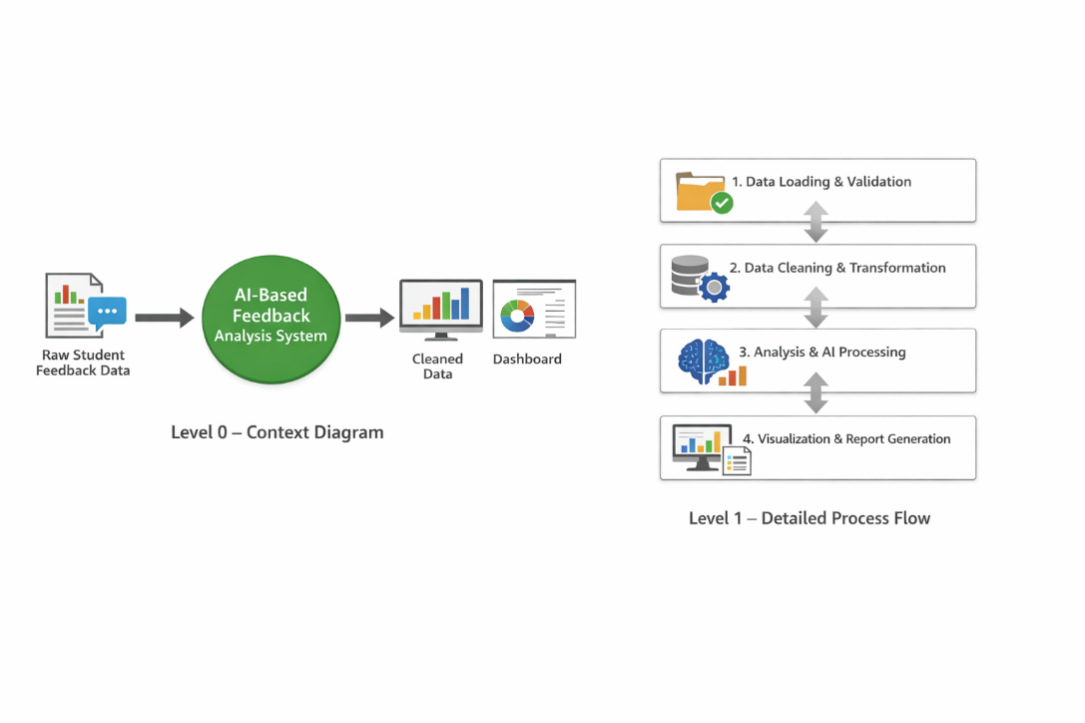

4.1 DFD Level 0 — Context Diagram
The Level 0 DFD represents the entire system as a single process.
Description:
- Input: Raw student feedback data (ratings + textual comments)
- Process: AI-Driven Feedback Analytics System
- Output: Cleaned data, analytical insights, dashboards, and reports
Textual Representation:
Raw Student Feedback Data
→ [AI-Based Feedback Analysis System]
→ Processed Data + Dashboard + Insight Reports
This level provides a high-level overview without going into internal processing details.

4.2 DFD Level 1 — Detailed Process Flow

The Level 1 DFD breaks down the main system into key sub-processes:

Table 1 Detailed Process Flow

Sub-process | Activities Performed | Tools Used | Output
1. Data Loading and Validation | • Importing input data into the system • Checking for completeness, format consistency, and accuracy • Identifying invalid or incomplete entries | Microsoft Excel | Validated dataset
2. Data Cleaning and Transformation | • Handling missing values and removing duplicates • Standardizing formats and rating scales • Structuring feedback parameters (engagement, clarity, etc.) • Preparing text data for analysis | Microsoft Excel | Cleaned and structured dataset
3. Analysis and AI Processing | • Performing quantitative analysis using pivot tables • Processing qualitative feedback using AI • Conducting sentiment analysis (Excellent, Good, Moderate) • Identifying patterns and trends | Microsoft Copilot | Analytical insights and sentiment results
4. Visualization and Report Generation | • Creating dashboards and visual reports • Generating charts, KPIs, and summaries • Presenting faculty performance and trends clearly | Power BI | Interactive dashboards and final reports

3.4 Advantages
• Automates repetitive data cleaning and preprocessing tasks, significantly reducing manual effort and saving time.
• Integrates both quantitative ratings and qualitative feedback, enabling a more comprehensive and holistic analysis of teaching effectiveness.
• Provides clear, interactive, and visually appealing insights through dashboards, making it easy for non-technical stakeholders to interpret results.
• Leverages AI tools such as Microsoft Copilot and chatbots to accelerate analysis, perform sentiment detection, and minimize human bias and errors.
• Enhances decision-making by identifying patterns, trends, strengths, and areas for improvement in a structured manner.
• Scalable in nature — the same framework can be extended to larger datasets, multiple departments, or even other domains beyond education.
• Cost-effective solution using widely available tools like Microsoft Excel and Power BI within the Microsoft 365 ecosystem.
• Supports data-driven academic planning and continuous improvement in teaching and learning outcomes.
• Enables sentiment-based insights from student comments, capturing the true voice of learners which is often missed in traditional systems.
• Provides a foundation for future enhancements such as predictive analytics, automated reporting systems, and real-time feedback integration.

3.5 Requirement Specification
Table 2 Hardware Requirements
Component | Specification
Processor | Intel Core i3 or higher (i5/i7 recommended)
RAM | Minimum 4 GB (8 GB recommended)
Storage | Minimum 50 GB free disk space
Display | 1366 x 768 resolution or higher
Internet | Required for Copilot / Chatbot access

Table 3 Software Requirements
Software | Details
Operating System | Windows 10 / 11 or macOS
Microsoft Excel | Microsoft 365 (Excel with Copilot) / Excel 2019+
Power BI Desktop | Latest version (free download from Microsoft)
Microsoft Copilot | Integrated via Microsoft 365 subscription
AI Chatbot | ChatGPT / Google Gemini / Microsoft Copilot (web)
Web Browser | Google Chrome / Microsoft Edge (latest version)

CHAPTER 4
Implementation and Results
This section presents the data cleaning process carried out on the student feedback dataset and highlights the improvements achieved after preprocessing.
Dataset Source: The dataset was manually created and structured as part of the project, incorporating realistic student feedback entries mapped to multiple faculty members across different departments.
Original Dataset Size: The raw dataset consisted of 585 rows and 12 columns, including both quantitative parameters (ratings) and qualitative feedback (text comments).
Issues Found: During initial inspection, the following issues were identified:
• Presence of missing/null values in some feedback parameters
• Duplicate records in a few entries
• Inconsistent rating scales (mix of 1–5 and 1–10 formats)
• Textual inconsistencies in feedback comments (spacing, casing, minor formatting errors)
• Irregular column naming and formatting issues
Cleaning Steps Applied: The data cleaning process was performed using Microsoft Excel and AI-assisted support:
• Removed duplicate records using Excel’s “Remove Duplicates” feature
• Handled missing values by replacing them with appropriate averages or default values
• Standardized all rating scales to a uniform 1–5 Likert scale
• Renamed and formatted column headers for consistency
• Cleaned textual feedback by correcting spacing, capitalization, and removing irrelevant characters
• Verified data types (numerical and text fields) for accuracy
• Used AI tools like Microsoft Copilot to validate cleaning logic and suggest improvements
Cleaned Dataset Size: After preprocessing, the dataset was refined to 550 rows and 12 columns, ensuring consistency, accuracy, and readiness for further analysis.

Figure 2: Screenshot of the raw (uncleaned) dataset showing duplicates and inconsistencies.
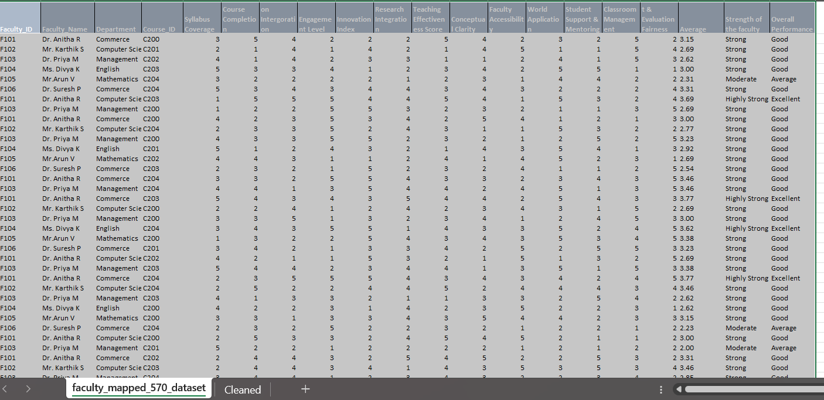
Figure 3: Screenshot of the cleaned dataset or a validation summary (showing standardized course names, corrected ratings, and consistent feedback text).
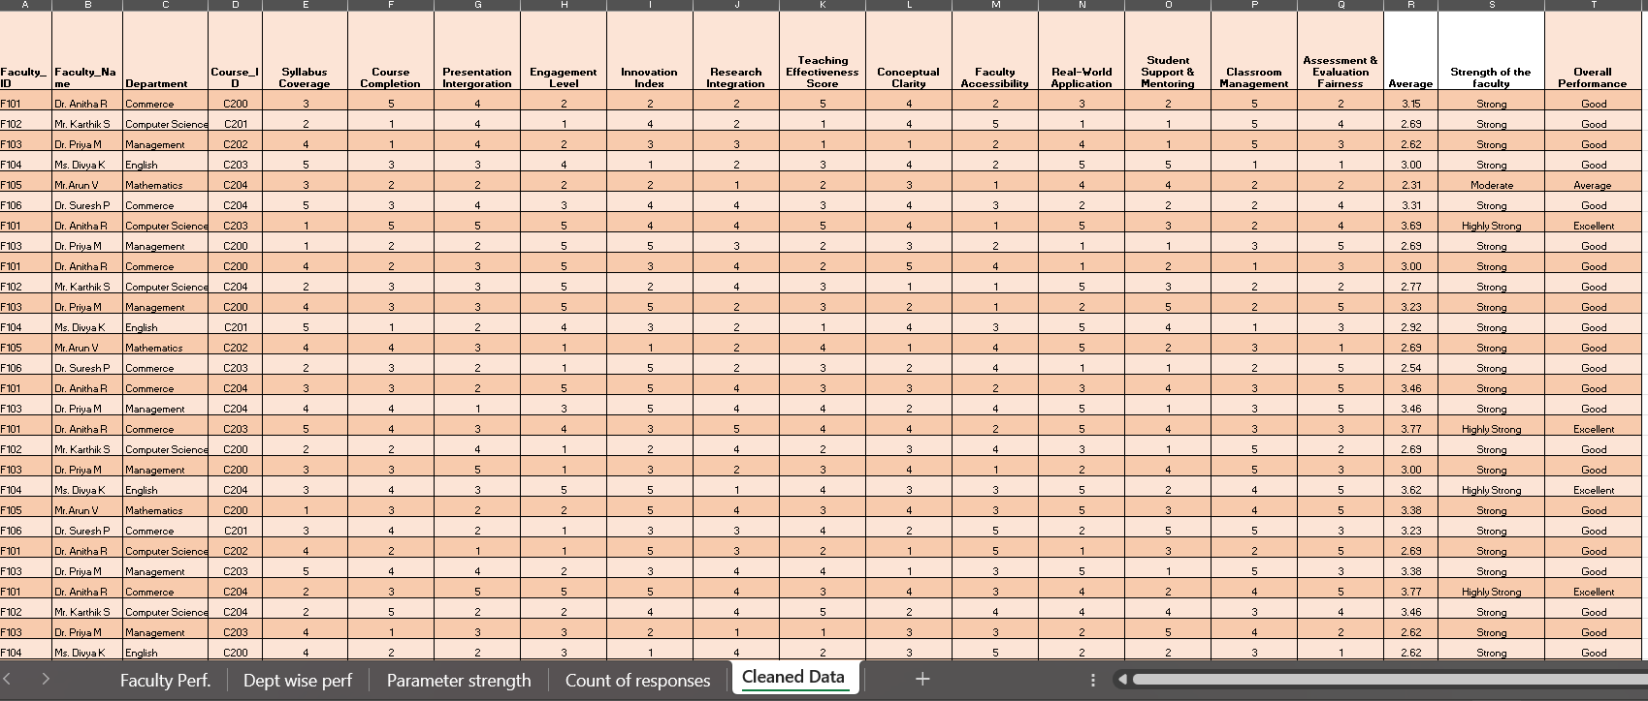

4.2 Visualization / Output Results
The cleaned dataset was analyzed and visualized using Excel PivotTables and Power BI dashboards. The following key outputs were generated:
Department-wise Faculty Performance Analysis
A bar chart showing average Overall Ratings across faculty members (Dr. Anitha R, Dr. Priya M, Dr. Suresh P, Mr. Karthik S, Mr. Arun V, and Ms. Divya K). This highlights differences where engagement scores are aggregated across different departments such as Commerce, Computer Science, English, Management, and Mathematics.
Table 4 Department-wise Faculty Performance
 | Average of Engagement Level of faculty
Department | Dr. Anitha R | Dr. Priya M | Dr. Suresh P | Mr. Karthik S | Mr.Arun V | Ms. Divya K | Grand Total
Commerce | 3.17 |  | 3.00 |  |  |  | 3.09
Computer Science | 3.27 |  | 2.95 | 2.83 |  | 2.84 | 2.90
English |  |  |  |  |  | 3.13 | 3.13
Management |  | 2.93 |  |  | 3.23 |  | 3.04
Mathematics |  |  |  |  | 3.03 |  | 3.03
Grand Total | 3.19 | 2.93 | 2.98 | 2.83 | 3.11 | 3.07 | 3.03

Figure 4 Department-wise Faculty Performance
Interpretation
The analysis reveals several key insights:
• Overall Performance:
The overall average engagement score across all departments is 3.03, indicating a moderate level of student engagement.
• Top Performing Faculty:
- Dr. Anitha R (3.19) has the highest overall engagement score, showing consistently strong performance, especially in Commerce and Computer Science.
- Mr. Arun V (3.11) also demonstrates good engagement, particularly in Management and Mathematics.
• Department-wise Insights:
- Commerce: Shows stable engagement with Dr. Anitha R (3.17) and Dr. Suresh P (3.00), resulting in a department average of 3.09.
- Computer Science: Displays varied performance, with Dr. Anitha R scoring highest (3.27), while others show slightly lower engagement, bringing the average to 2.90.
- English: Achieves a strong score (3.13), driven primarily by Ms. Divya K.
- Management: Records balanced performance with contributions from Dr. Priya M (2.93) and Mr. Arun V (3.23), averaging 3.04.
- Mathematics: Maintains moderate engagement (3.03) with Mr. Arun V as the key contributor.
Table 5 Faculty Performance Summary
Faculty Performance Summary
Name of the Faculty | Average of Teaching Effectiveness Score | Average of Conceptual Clarity | Average of Student Support & Mentoring
Dr. Anitha R | 3.23 | 3.13 | 3.31
Dr. Priya M | 3.09 | 2.90 | 2.99
Dr. Suresh P | 2.87 | 2.81 | 2.99
Mr. Karthik S | 2.82 | 2.79 | 3.32
Mr.Arun V | 3.07 | 3.11 | 3.12
Ms. Divya K | 3.05 | 3.20 | 3.15
Grand Total | 3.03 | 3.00 | 3.14
The above table and chart present a Faculty Performance Summary based on three key evaluation parameters: Teaching Effectiveness Score, Conceptual Clarity, and Student Support & Mentoring. The data has been analysed using pivot tables in Microsoft Excel, providing both numerical and visual insights into faculty performance.
The tabular format offers a clear comparison of average scores for each faculty member, while the bar chart visually represents variations across the three parameters. This combined representation helps in identifying strengths, performance gaps, and overall teaching quality among faculty members.

Figure 5 Faculty Performance Summary
Interpretation
The analysis provides the following key insights:
• Overall Performance Trends:
The overall average scores are 3.03 (Teaching Effectiveness), 3.00 (Conceptual Clarity), and 3.14 (Student Support & Mentoring), indicating that faculty members perform relatively better in mentoring and student support compared to conceptual clarity.
• Top Performing Faculty:
- Dr. Anitha R stands out with the highest teaching effectiveness (3.23) and strong mentoring (3.31), indicating consistent high performance.
- Ms. Divya K excels in conceptual clarity (3.20) and maintains balanced performance across all parameters.
- Mr. Arun V shows stable and above-average performance across all three metrics.
• Student Support & Mentoring Strength:
This parameter has the highest overall average (3.14), with Mr. Karthik S (3.32) and Dr. Anitha R (3.31) leading, indicating strong faculty involvement in student guidance.
• Conceptual Clarity Insights:
Conceptual clarity has a slightly lower overall average (3.00), suggesting a potential area for improvement. Faculty like Dr. Suresh P (2.81) and Mr. Karthik S (2.79) show comparatively lower scores, indicating the need for strengthening subject delivery techniques.
• Teaching Effectiveness Observations:
While most faculty members maintain scores above 3, Dr. Suresh P (2.87) and Mr. Karthik S (2.82) fall slightly below, highlighting opportunities for enhancing classroom engagement and delivery methods.
• Balanced Performers:
Faculty such as Mr. Arun V and Ms. Divya K demonstrate consistent performance across all parameters, reflecting a well-rounded teaching approach.
The analysis highlights that while faculty members are generally effective in mentoring and student support, there is scope to enhance conceptual clarity and teaching effectiveness for certain individuals. The visualization enables easy comparison and supports data-driven decisions for faculty development, training, and continuous improvement in teaching quality.
Table 6 – Course-Wise Satisfaction
Count of Strength of the faculty |  | CourseWiseSatisfaction
Row Labels | Highly Strong | Moderate | Needs Improvement | Strong | Grand Total
C200 | 12.05% | 6.02% | 1.20% | 80.72% | 100.00%
C201 | 12.50% | 9.72% | 0.00% | 77.78% | 100.00%
C202 | 10.56% | 10.56% | 1.41% | 77.46% | 100.00%
C203 | 15.73% | 11.24% | 0.00% | 73.03% | 100.00%
C204 | 6.32% | 9.47% | 1.05% | 83.16% | 100.00%
Grand Total | 11.93% | 9.82% | 0.70% | 77.54% | 100.00%

Figure 6 – Course-Wise Satisfaction

Interpretation
The pivot table and pie chart present a comparative analysis of faculty strength levels across five courses (C200–C204), categorized as Highly Strong, Strong, Moderate, and Needs Improvement.
- Overall Performance Trend
  - A significant majority of faculty performance falls under the “Strong” category (77.54%), indicating a consistently good level of teaching effectiveness across all courses.
  - The “Highly Strong” category (11.93%) reflects a smaller yet notable group of top-performing faculty.
- Minimal Areas of Concern
  - The “Needs Improvement” category is very low (0.70%), suggesting that very few faculty members require attention or support.
  - This indicates a generally high standard of teaching quality.
- Course-wise Observations
  - C204 (83.16%) has the highest percentage in the Strong category, showing the most consistent performance.
  - C203 (15.73%) stands out with the highest proportion of Highly Strong faculty, indicating excellence in teaching quality.
  - C200 (1.20%) and C202 (1.41%) show slightly higher “Needs Improvement” percentages compared to others, though still minimal.
- Moderate Performers
  - Around 9.82% of faculty fall under the Moderate category, suggesting scope for improvement to move them into higher performance levels.
Pie Chart Insight:
- The pie chart visually highlights the distribution of Highly Strong faculty across courses, with C203 contributing the largest share, followed by C201 and C200.

Table 7 – Faculty overall Performance Analysis
Faculty overall Performance Analysis
Count of Strength of the faculty | Column Labels
Row Labels | Average | Excellent | Good | Poor | Grand Total
Dr. Anitha R | 6 | 12 | 67 | 1 | 86
Dr. Priya M | 6 | 9 | 75 | 1 | 91
Dr. Suresh P | 15 | 9 | 84 |  | 108
Mr. Karthik S | 7 | 11 | 52 | 2 | 72
Mr.Arun V | 12 | 9 | 101 |  | 122
Ms. Divya K | 10 | 18 | 63 |  | 91
Grand Total | 56 | 68 | 442 | 4 | 570

Figure 7 – Faculty overall Performance Analysis

Interpretation
Overall Distribution Insight
- The majority of ratings fall under “Good” (442 out of 570), indicating that overall teaching performance is consistently satisfactory across faculty.
- “Excellent” (68) ratings are comparatively low, suggesting scope for improvement toward high-quality teaching excellence.
- Very few “Poor” (4) ratings indicate that serious performance issues are minimal.

Faculty-wise Performance Insights
Mr. Arun V
- Highest total responses (122) and highest “Good” ratings (101)
Indicates strong consistency and reliability in teaching performance
Dr. Suresh P
- High total (108) with strong Good (84) and moderate Average (15)
Demonstrates stable performance with room to improve towards excellence
Dr. Priya M
- High Good ratings (75) with low Poor (1)
Shows consistent teaching quality with minimal negative feedback
Dr. Anita R
- Balanced distribution with 12 Excellent and 67 Good
Indicates good performance with some recognition for excellence
Ms. Divya K
- Highest Excellent ratings (18) among all faculty
Reflects strong teaching impact and student appreciation
Mr. Karthik S
- Slightly higher Poor ratings (2) compared to others
Suggests minor areas needing improvement despite overall good performance

Figure 8 : Screenshot of the main dashboard
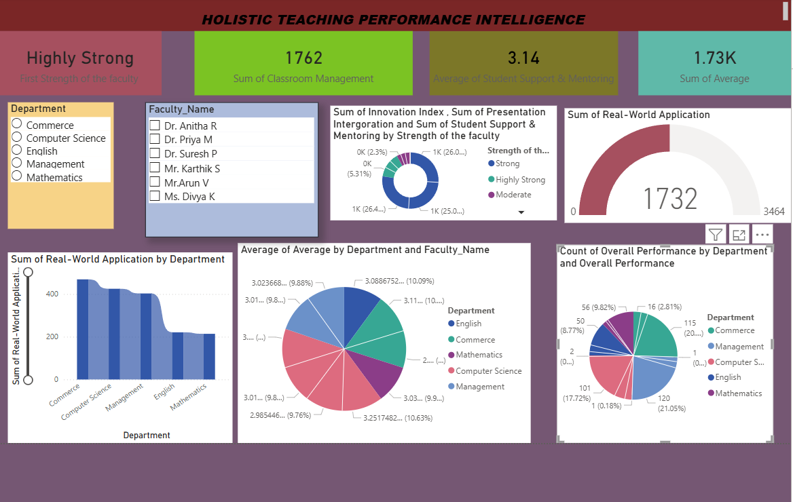
4.3 AI Tool Integration Results
In this project, a combination of Microsoft Copilot (Excel/Power BI integration) and ChatGPT was utilized to ensure both quantitative accuracy and qualitative depth. Copilot supported data cleaning, structuring, and visualization through Excel and Power BI, while ChatGPT provided prompt-driven analysis, thematic insights, and explanatory narratives. Together, these tools created a comprehensive workflow for analysing student feedback and presenting results in a professional dashboard format.

Table 8 Tools Used in Project
Tool / Platform | Purpose / Usage
Microsoft Copilot (Excel Integration) | Cleaning datasets, generating PivotTables, and dashboard tables.
Microsoft Copilot (Power BI Integration) | Interactive visualizations and charts
ChatGPT (Prompt-Driven Analysis) | Generating explanations, recommendations, thematic summaries, and interpretations.
Excel (Data Cleaning & Structuring) | Removing duplicates and handling missing values
PivotTables & Slicers (Excel) | Course-wise satisfaction trends, recommendation analysis, and faculty performance comparisons.

Table 9 List of Prompts Used in Project

Prompt | Description
Data Cleaning & Preparation | Removing duplicates and handling missing values
Department-wise Faculty Performance | Show department-wise comparisons and highlight top-performing departments.”
Faculty Performance Summary | “Generate a summary of each faculty member’s performance, including average scores across all parameters, strengths, and areas of improvement.”
Faculty Performance Comparison | “Compare the performance of all faculty members using key parameters such as engagement, clarity, innovation, and accessibility. Present the comparison in a tabular and visual format.”
Course-Wise Satisfaction | “Analyze student feedback to determine course-wise satisfaction levels. Calculate average ratings per course and identify the highest and lowest rated courses.”
Faculty overall Performance Analysis | “Create an overall performance index for each faculty member by combining all evaluation parameters. Rank faculty based on their overall performance scores.”
Thematic Feedback Insights | “Analyze qualitative student feedback comments to identify common themes such as teaching effectiveness, communication, and engagement. and summarize key insights.”
Overall Dashboard Summary | “Create a dashboard summary showing key insights including top-performing faculty, department performance, course satisfaction, and overall trends using charts and KPIs.”
Diagrammatic Explanations | “Generate visual representations such as bar charts, pie charts, to explain faculty performance, department comparisons, and student satisfaction clearly.”

CHAPTER 5 — DISCUSSION AND CONCLUSION
5.1 Key Findings
5.1.1 Data Quality and Categorisation
The data cleaning and preprocessing stage significantly improved the reliability of the dataset. The original dataset contained inconsistencies such as missing values, duplicate records, and mixed rating scales. After cleaning, the dataset was standardized to a uniform 1–5 Likert scale and reduced from 585 to 570 records. This ensured higher accuracy in analysis and improved the credibility of insights generated through dashboards.
5.1.2 Quantitative Insights
The quantitative analysis revealed that overall faculty performance is consistently moderate to strong across departments, with an average score of approximately 3.03.
- A large proportion of feedback falls under the “Good” category, indicating satisfactory teaching performance.
- Faculty such as Dr. Anitha R and Mr. Arun V emerged as top performers with strong engagement and teaching effectiveness scores.
- The parameter Student Support & Mentoring (3.14) scored higher than others, highlighting faculty strength in student interaction.
- Conceptual Clarity (3.00) showed relatively lower scores, indicating an area for improvement.
5.1.3 Qualitative Insights
The integration of AI-driven sentiment analysis provided deeper insights into student feedback:
- Most student comments reflected positive sentiment, aligning with strong quantitative scores.
- Recurring themes included appreciation for faculty support, communication, and engagement.
- Areas needing improvement included clarity of explanation and innovative teaching methods.
- Thematic analysis helped identify patterns that are not visible through numerical data alone.
5.1.4 AI-Driven Efficiency Gains
The use of AI tools such as Microsoft Copilot and ChatGPT significantly enhanced the efficiency of the project:
- Reduced time for data cleaning, summarization, and report generation.
- Automated generation of insights, interpretations, and visual explanations.
- Enabled faster dashboard creation and decision-making.
Overall, AI tools improved productivity by reducing manual effort and increasing analytical depth.

5.2 Limitations
Despite its effectiveness, the project has certain limitations:
- The dataset used was sample-based and may not fully represent real-world institutional diversity.
- AI-generated insights require human validation to ensure contextual accuracy.
- The system does not support real-time data integration or automation.
- Feedback bias due to uneven student participation was not fully addressed.
- The analysis is limited to descriptive insights and does not include predictive modelling.

5.3 Future Work
The project can be further enhanced through the following improvements:
- Integration of real-time feedback systems using APIs or Power Automate.
- Implementation of machine learning models for predictive analysis and trend forecasting.
- Inclusion of multi-source feedback such as peer reviews and self-assessment.
- Development of a web-based or mobile interface for easier accessibility.
- Creation of a standardized AI prompt library for educational analytics.
- Expansion of the dataset across multiple institutions for broader insights.

5.4 Conclusion
This project successfully demonstrates the application of Artificial Intelligence and data analytics in transforming traditional student feedback systems into a holistic and insight-driven framework. By integrating quantitative analysis with AI-based sentiment analysis, the study provides a more comprehensive evaluation of faculty performance.
The use of tools such as Microsoft Excel, Power BI, Microsoft Copilot, and ChatGPT enabled efficient data processing, visualization, and interpretation. The results highlight that while overall teaching performance is satisfactory, there are opportunities to enhance conceptual clarity and achieve higher levels of teaching excellence.
All the objectives of the project were successfully achieved, including data cleaning, analysis, visualization, and AI integration. The developed dashboard provides actionable insights that can support academic decision-making and continuous improvement in teaching practices.
In conclusion, this project adds significant value by demonstrating how AI-powered tools can enhance the quality, efficiency, and depth of feedback analysis, thereby contributing to improved educational outcomes and data-driven institutional growth.

REFERENCES

[1] Microsoft Corporation. Microsoft Excel Documentation. Available at: https://support.microsoft.com/excel
[2] Microsoft Corporation. Power BI Documentation. Available at: https://learn.microsoft.com/power-bi
[3] Microsoft Copilot. AI-Powered Productivity Tool Overview. Available at: https://copilot.microsoft.com
[4] Edunet Foundation. AICW Fellowship Program Guidelines, 2026.
[5] OpenAI. ChatGPT Documentation and Usage Guide. Available at: https://platform.openai.com
[6] Google. Google Gemini AI Documentation. Available at: https://ai.google.dev
[7] Sentiment Analysis. Liu, B. (2012). Sentiment Analysis and Opinion Mining. Morgan & Claypool Publishers.
[8] Data Analytics. Provost, F., & Fawcett, T. (2013). Data Science for Business. O’Reilly Media.
[9] Business Intelligence. Sharda, R., Delen, D., & Turban, E. (2018). Business Intelligence, Analytics, and Data Science: A Managerial Perspective. Pearson.
[10] Microsoft Power BI. Getting Started with Power BI Dashboards. Microsoft Learn.
[11] Microsoft Excel. Excel Functions and Formulas Guide. Microsoft Learn.
[12] Artificial Intelligence. Russell, S., & Norvig, P. (2021). Artificial Intelligence: A Modern Approach. Pearson.

APPENDICES

Appendix A — Sample Dataset

Sample Raw Dataset (First 20 Rows)
Faculty_ID | Faculty_Name | Department | Course_ID | Syllabus Coverage | Course Completion | Presentation Intergoration | Engagement Level | Innovation Index | Research Integration | Teaching Effectiveness Score | Conceptual Clarity | Faculty Accessibility | Real-World Application | Student Support & Mentoring | Classroom Management | Assessment & Evaluation Fairness | Average | Strength of the faculty | Overall Performance
F101 | Dr. Anitha R | Commerce | C200 | 3 | 5 | 4 | 2 | 2 | 2 | 5 | 4 | 2 | 3 | 2 | 5 | 2 | 3.15 | Strong | Good
F102 | Mr. Karthik S | Computer Science | C201 | 2 | 1 | 4 | 1 | 4 | 2 | 1 | 4 | 5 | 1 | 1 | 5 | 4 | 2.69 | Strong | Good
F103 | Dr. Priya M | Management | C202 | 4 | 1 | 4 | 2 | 3 | 3 | 1 | 1 | 2 | 4 | 1 | 5 | 3 | 2.62 | Strong | Good
F104 | Ms. Divya K | English | C203 | 5 | 3 | 3 | 4 | 1 | 2 | 3 | 4 | 2 | 5 | 5 | 1 | 1 | 3.00 | Strong | Good
F105 | Mr.Arun V | Mathematics | C204 | 3 | 2 | 2 | 2 | 2 | 1 | 2 | 3 | 1 | 4 | 4 | 2 | 2 | 2.31 | Moderate | Average
F106 | Dr. Suresh P | Commerce | C204 | 5 | 3 | 4 | 3 | 4 | 4 | 3 | 4 | 3 | 2 | 2 | 2 | 4 | 3.31 | Strong | Good
F101 | Dr. Anitha R | Computer Science | C203 | 1 | 5 | 5 | 5 | 4 | 4 | 5 | 4 | 1 | 5 | 3 | 2 | 4 | 3.69 | Highly Strong | Excellent
F103 | Dr. Priya M | Management | C200 | 1 | 2 | 2 | 5 | 5 | 3 | 2 | 3 | 2 | 1 | 1 | 3 | 5 | 2.69 | Strong | Good
F101 | Dr. Anitha R | Commerce | C200 | 4 | 2 | 3 | 5 | 3 | 4 | 2 | 5 | 4 | 1 | 2 | 1 | 3 | 3.00 | Strong | Good
F102 | Mr. Karthik S | Computer Science | C204 | 2 | 3 | 3 | 5 | 2 | 4 | 3 | 1 | 1 | 5 | 3 | 2 | 2 | 2.77 | Strong | Good
F103 | Dr. Priya M | Management | C200 | 4 | 3 | 3 | 5 | 5 | 2 | 3 | 2 | 1 | 2 | 5 | 2 | 5 | 3.23 | Strong | Good
F104 | Ms. Divya K | English | C201 | 5 | 1 | 2 | 4 | 3 | 2 | 1 | 4 | 3 | 5 | 4 | 1 | 3 | 2.92 | Strong | Good
F105 | Mr.Arun V | Mathematics | C202 | 4 | 4 | 3 | 1 | 1 | 2 | 4 | 1 | 4 | 5 | 2 | 3 | 1 | 2.69 | Strong | Good
F106 | Dr. Suresh P | Commerce | C203 | 2 | 3 | 2 | 1 | 5 | 2 | 3 | 2 | 4 | 1 | 1 | 2 | 5 | 2.54 | Strong | Good
F101 | Dr. Anitha R | Commerce | C204 | 3 | 3 | 2 | 5 | 5 | 4 | 3 | 3 | 2 | 3 | 4 | 3 | 5 | 3.46 | Strong | Good
F103 | Dr. Priya M | Management | C204 | 4 | 4 | 1 | 3 | 5 | 4 | 4 | 2 | 4 | 5 | 1 | 3 | 5 | 3.46 | Strong | Good
F101 | Dr. Anitha R | Commerce | C203 | 5 | 4 | 3 | 4 | 3 | 5 | 4 | 4 | 2 | 5 | 4 | 3 | 3 | 3.77 | Highly Strong | Excellent
F102 | Mr. Karthik S | Computer Science | C200 | 2 | 2 | 4 | 1 | 2 | 4 | 2 | 3 | 4 | 3 | 1 | 5 | 2 | 2.69 | Strong | Good
F103 | Dr. Priya M | Management | C200 | 3 | 3 | 5 | 1 | 3 | 2 | 3 | 4 | 1 | 2 | 4 | 5 | 3 | 3.00 | Strong | Good
F104 | Ms. Divya K | English | C204 | 3 | 4 | 3 | 5 | 5 | 1 | 4 | 3 | 3 | 5 | 2 | 4 | 5 | 3.62 | Highly Strong | Excellent
Appendix B — Key Excel Formulas / DAX Measures Used
- =AVERAGEIF (Faculty_Name_Range) calculate average ratings per faculty
- Overall Performance Score = (Engagement + Clarity + Innovation + Accessibility) / 4
- Faculty performance is measured by the aerage of (Teaching_Effectiveness + Conceptual_Clarity+ Student support & mentoring
- Department wise performance is measured with the faculty average engagement level.
- Student Support Score = (Accessibility + Mentoring) / 2
- Average of course wise satisfaction is grouped by strength of faculty.
Appendix C — AI Prompts Used
- Prompt 1: Analyze the qualitative student feedback comments in the dataset and summarize recurring themes related to teaching effectiveness, engagement, conceptual clarity, and student support.
- Prompt 2: “Based on the faculty performance data and low engagement scores identified in the dataset, generate actionable recommendations to improve teaching quality, student interaction, and classroom engagement.”
- Prompt 3: “Examine the feedback dataset and identify strengths and weaknesses of each faculty member using key parameters such as teaching effectiveness, conceptual clarity, and mentoring.
- Prompt 4: “Create a professional summary report of student satisfaction trends across courses by analysing categories such as Highly Strong, Strong, Moderate, and Needs Improvement.

Appendix D — Screenshot Gallery
- Figure A1: PivotTable Comprehensive Student Feedback Analysis Dashboard
